**CMPE 207 : Network Programming and Applications**

**Homework 2: Simple TCP Server**

**Submitted by Team Network Ninjas (Shashank Bheemanapalli, Vidhatri Milind Joshi and Sahiti Shankar Varada)**

1. Text content is uploaded onto the server and the server is made open for the clients to connect.

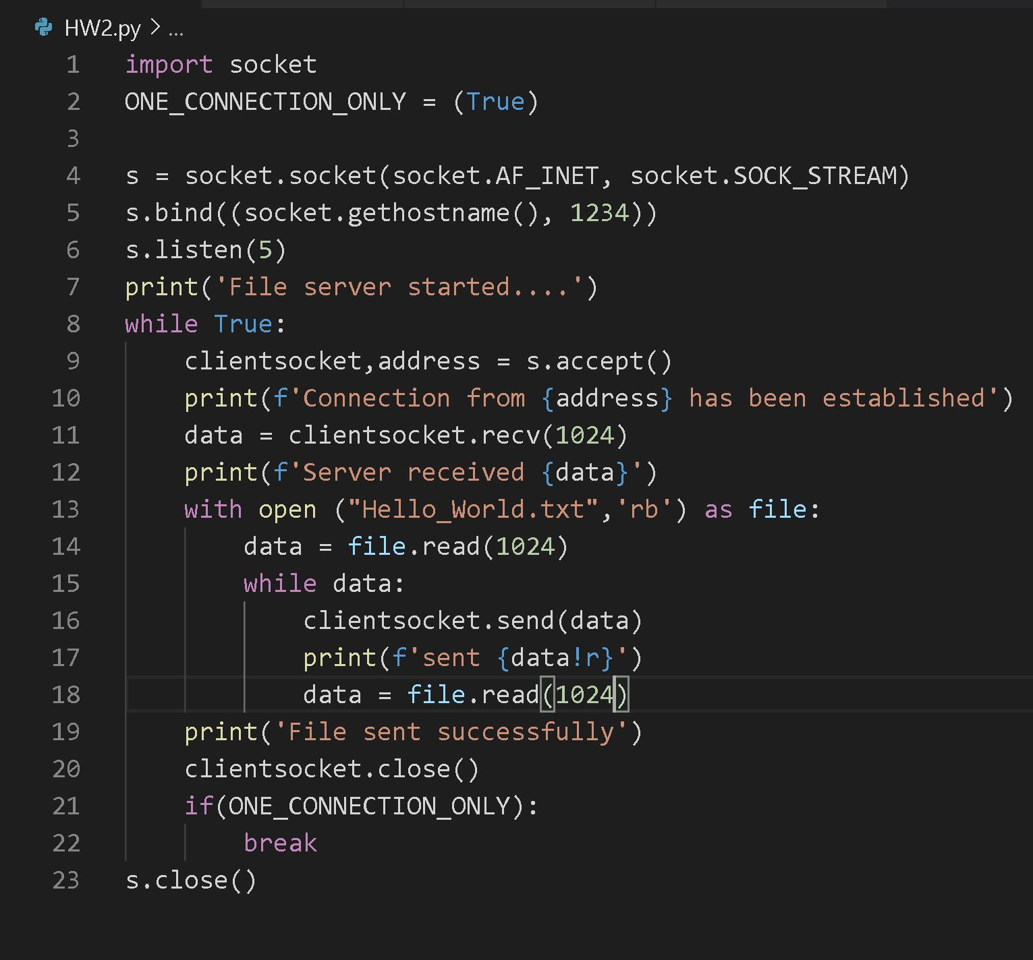

1. Client connects to the server to read the text content.

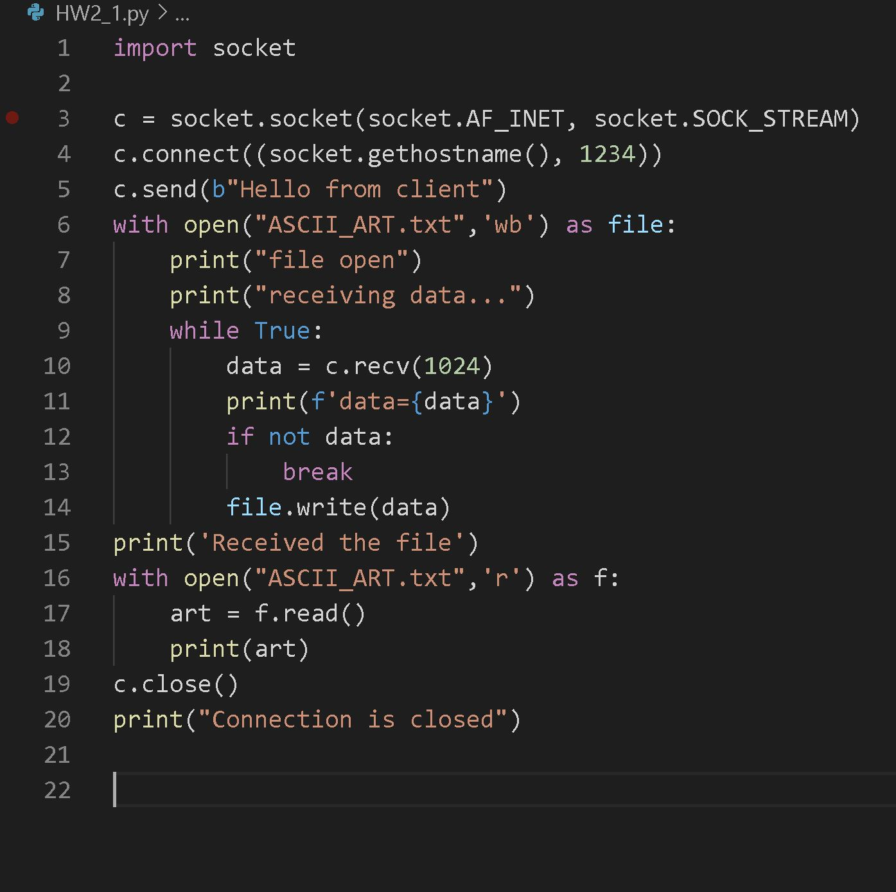

1. Here is the screenshots of the output ( text file content)

